Use of AI in the group project
Group 29 – Martin Bath

Project – Android App Card game called Cardrules where the rules change and the AI acts as the opponent, with either knowing of oblivious of the rules and attempts to win.

The original intention was to write a pseudo AI routine to go through available rules and by allocating a score to each, attempt to select a winning strategy. During one of the early scrums, at the suggestion of the tutor, this was amended to using AI or AI agent.
Various AI software tools were investigated, including ChatGPT, Google Gemini, Claude, Perplexity, Meta AI. XGrok, and Copilot for cost, functionality, documentation (Wotnot.io 2025) . In reading around the topic, it became clear that the AI software landscape is fast moving and volatile. Software chosen now, may not be available come May / June 2026. Chang (2025) notes that AI companies often plan only a few months ahead because the technology is evolving so fast.
This volatility made the overhead of creating AI agents in any one piece of software particularly unattractive, if it risked the requirement of rewriting it in a few months, adjacent to the project deadline. The choice came down to software from a major player, likely to be around for the next 12 months, at least, together with documentation, support from the development community and a free model to work with on a conversational level.

Google Gemini appeared to be the front runner for this and there was also a Unity demo available demonstrating calls to Gemini.
(https://github.com/UnityGameStudio/Gemini-Unity-Package)
The options for Gemini API packages are shown below.
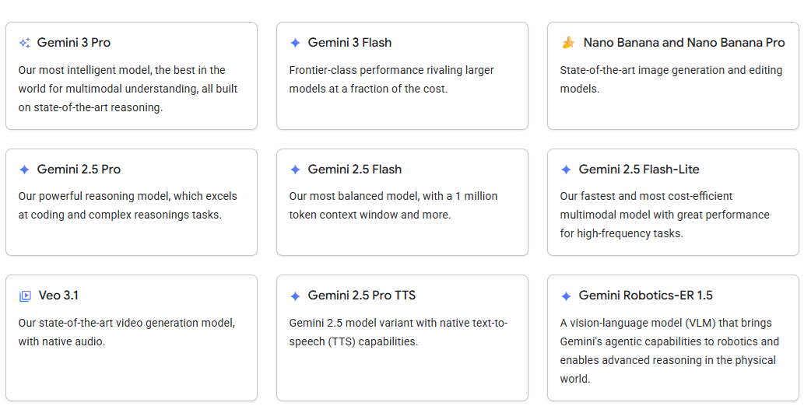
The complexity of the tasks being presented to Gemini were relatively low and the response time had to be fast enough to ensure the user’s interest was maintained, so the 2.5 Flash-lite package was chosen as the initial selection and an API key was created for it. This allowed the flexibility of moving to the more powerful versions if the chosen on did not fulfil the requirements.

The availability of the Unity demo sealed the choice of using Gemini so the next step was to load Unity, load the demo and get it working. The size of Unity objects proved a headache to save the code with Github but eventually, this was solved using tips from the internet regarding which libraries to ignore and which to include.
The demo can be seen below:
Gemini Unity demo downloaded from Github

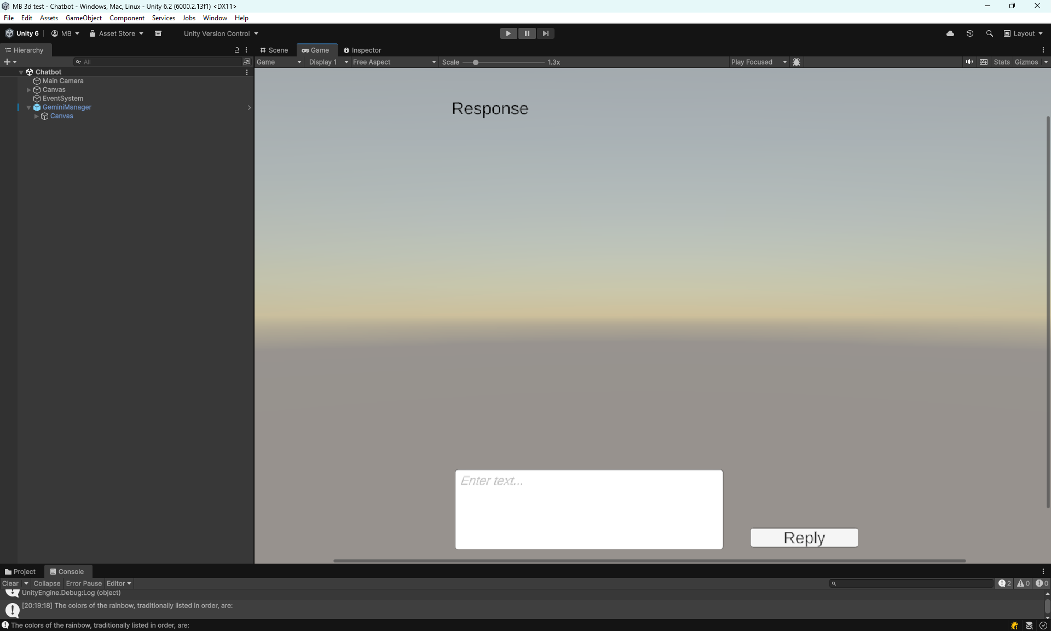
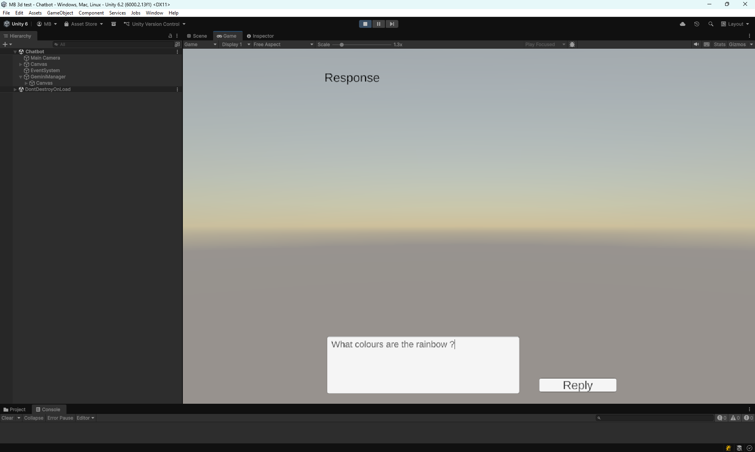
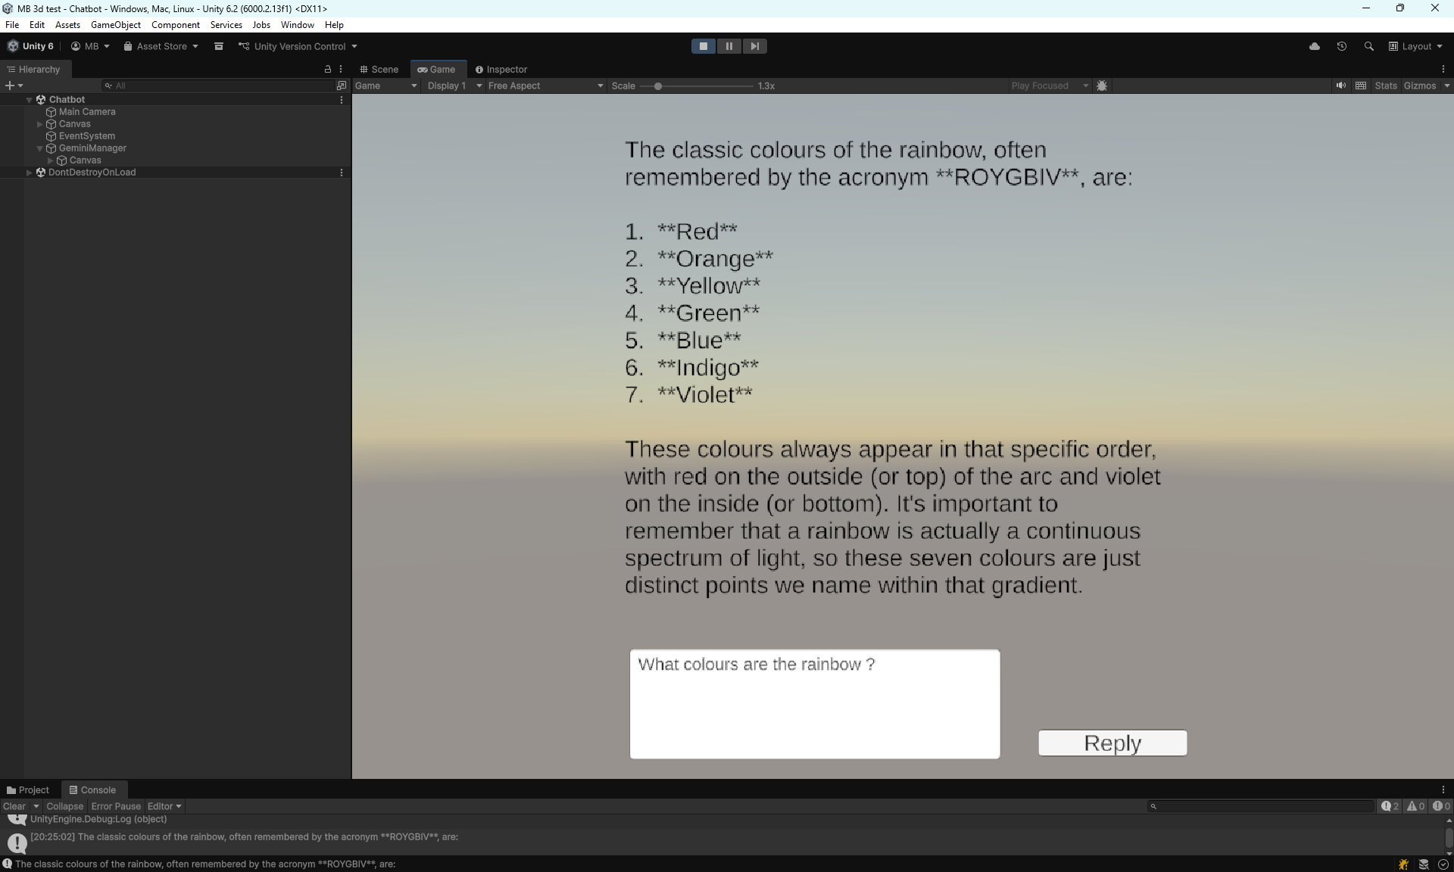

The demo was used to investigate emulating a game in Gemini, the screenshots of which are shown in Appendix “Emulation”, along with some initial observations. As a result of these tests, it was decided that the control of the game will be handled by our application and Gemini used to take the opponents go only, rather than using AI to perform all tasks.

A version of the demo was created where we pass criteria to Gemini and receive the response. After several iterations of this, a working AI opponent was created.
Screenshots from this version shown below.
First image showing the rules and card state passed to Gemini (hard coded for testing purposes)
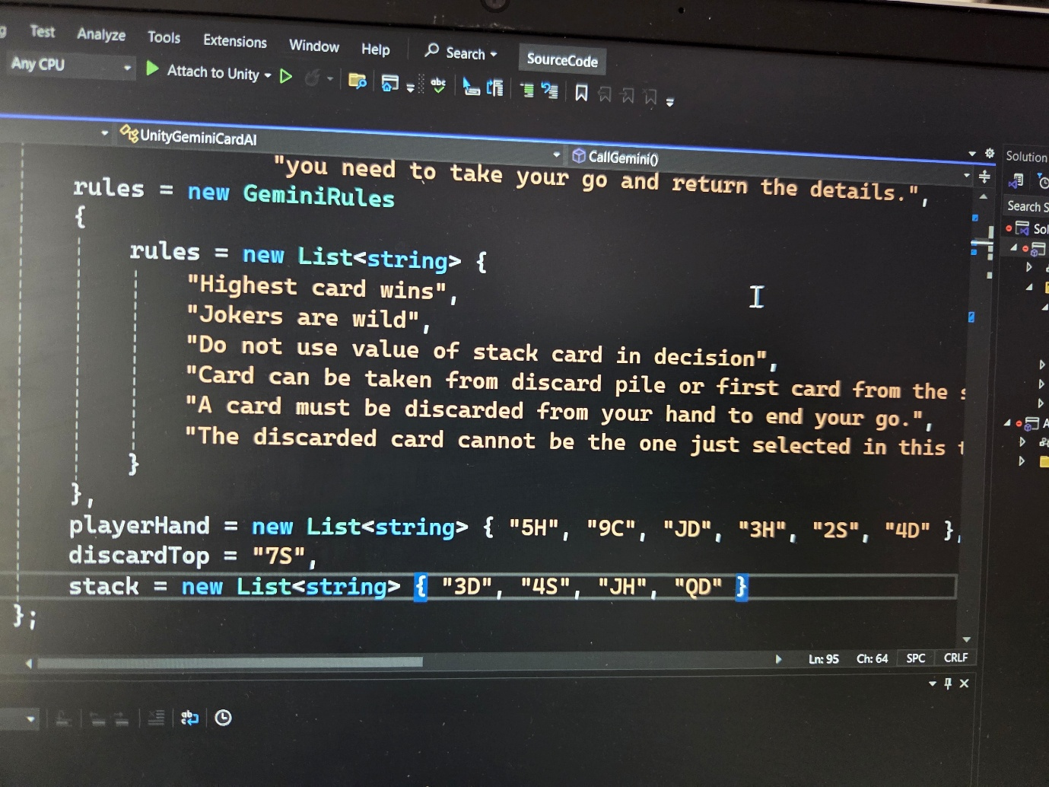
Second image showing the response. To enable the gamestate to be recorded in our app, AI was required to return the action taken, i.e. did it take a card off the stack or the discard pile), which card it then discarded, and to state what their hand contained at the end of their turn.
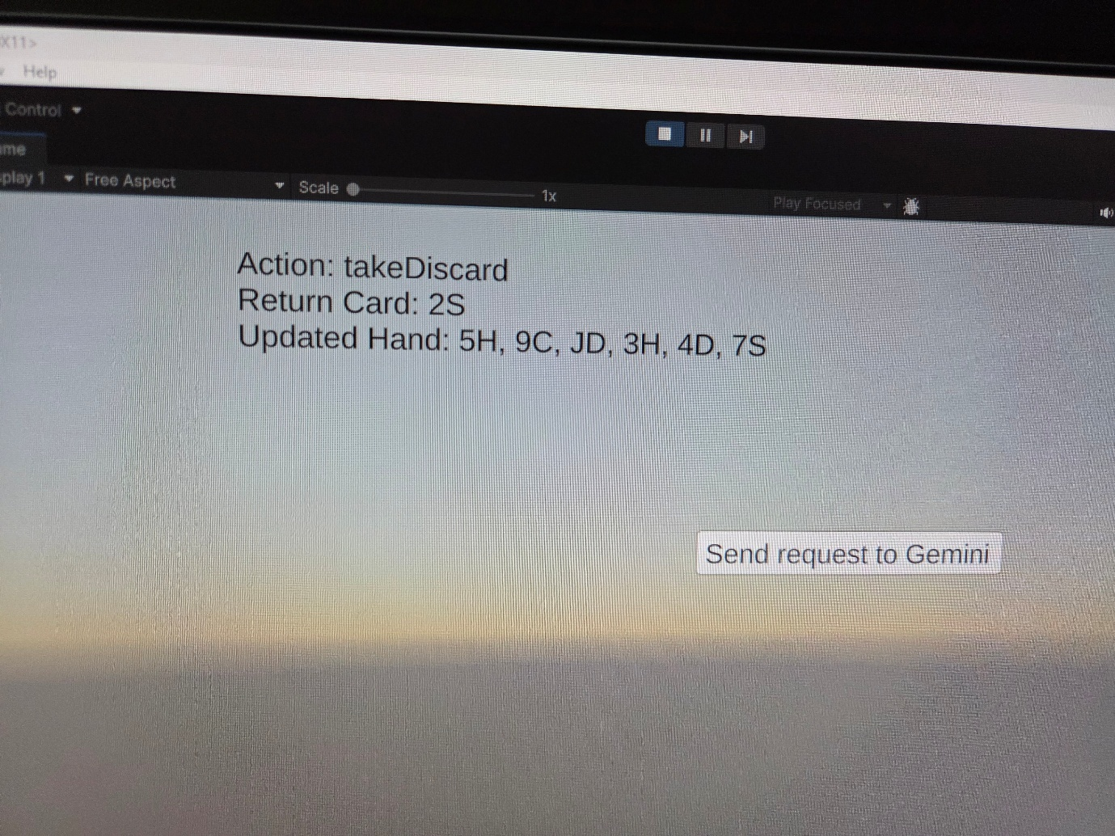

This formed the basis for the next step of the process where the graphics and gameplay were integrated to produce a working prototype of a game where rules were sent to Gemini.
The final version, in the second semester, will need to handle a list of possible solutions where AI does not know which rules are in play.

Appendix “Emulation”
Results of emulating a game in initial chatbot demo.
We are playing a card game. Please create a 7 digit reference for this card game instance.


For card game 4817392, please shuffle the deck with a standard card deck
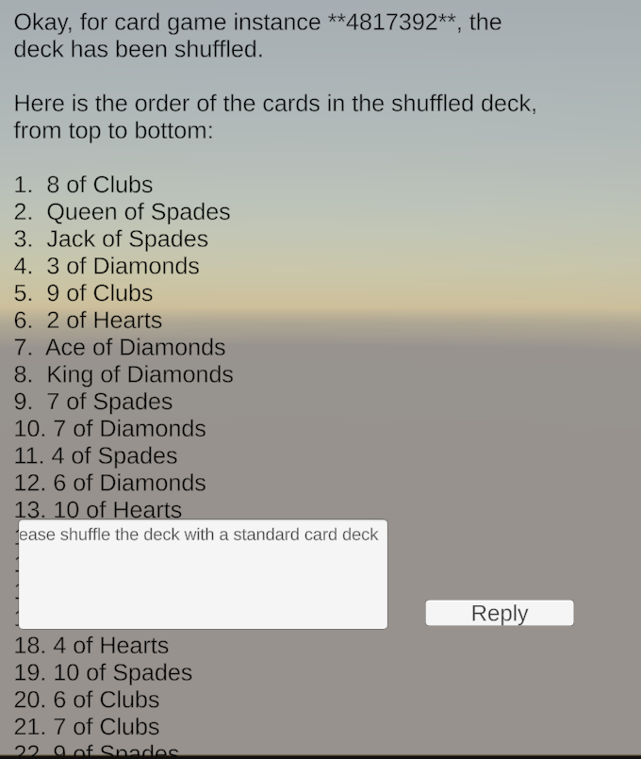
For card game 4817392, please shuffle the deck with a standard card deck again
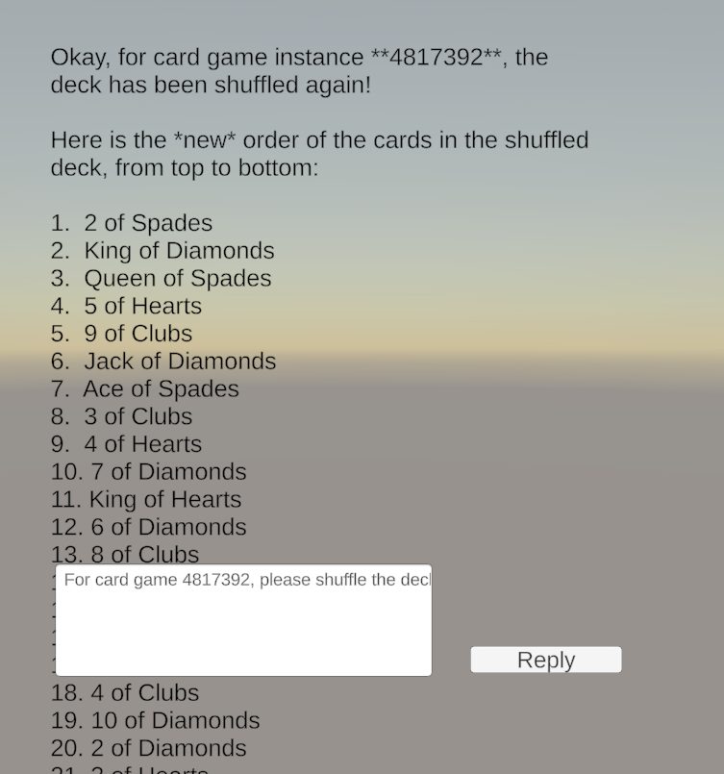

For card game 4817392, deal 4 players, 7 cards each and turn over the first card of the stack
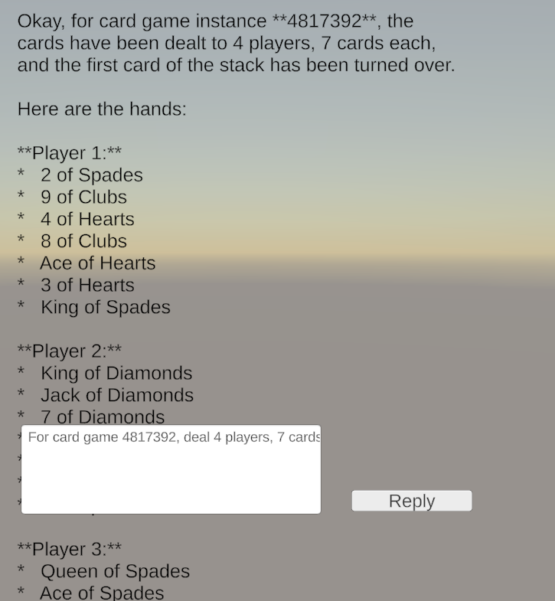

If you were player 1, in a game of rummy, which card would you lay first?
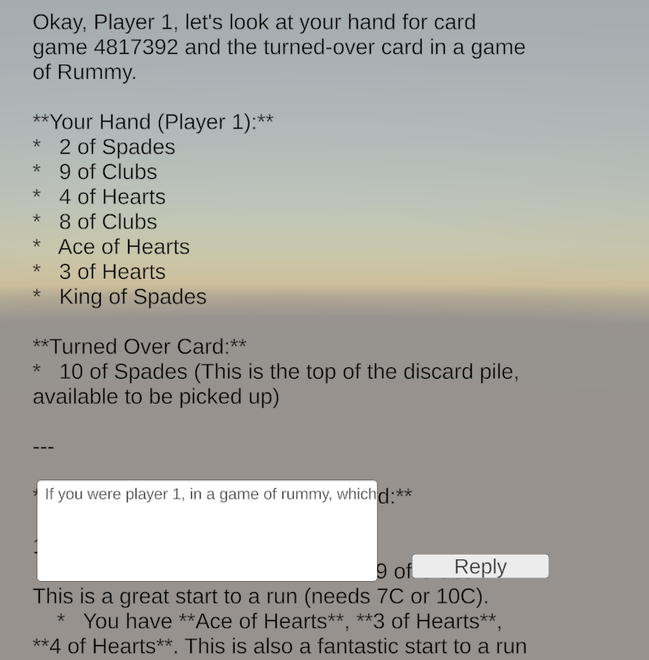

Observations
AI played in cat persona. Removed this setting.
Gave set of rules and tried to play. AI revealed the top card of the stack (as well as the reveal card).
Jumped turns when given instructions. Had to be told to not take the other players goes.
Showed explanation as default.
Confusion between “discard” – verb and “discard pile” – noun. Suggest we rename these.
AI took weaker card and admitted it when questioned.
Doesn’t take it’s go automatically, even though it was told to.
Duplicated a card. (2 King of Clubs in the deck)
Added a new rule. Next move correctly trapped the new rule violation

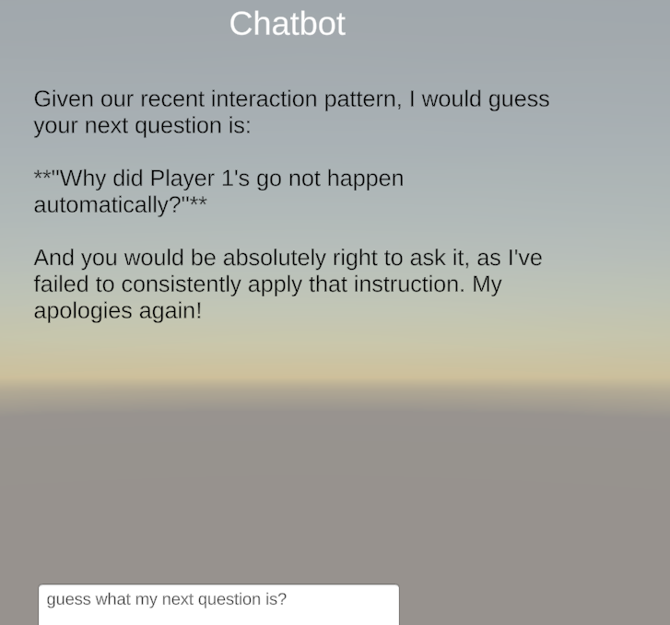

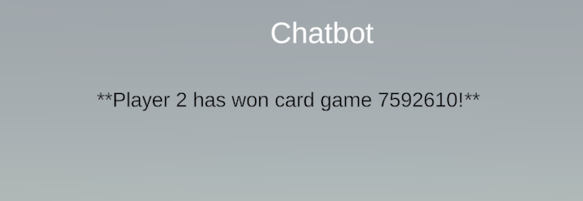Deal

Created a new game id with same rules. Asked how many games were in operation., response was 1. Asked who won previous game number and correct response was received.

---------- End of Report -----------

